Process for Requesting Carl the Career Bear (Lifesize) for Career Related events – October 28, 2020.
Program History: Carl started as a program to introduce elementary students to careers in our region. This program has grown in dynamics to where Carl is present in all grades K-12.
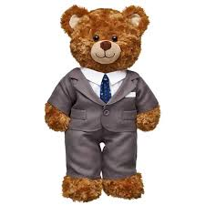
Introducing: Carl the Career Bear (teddy bear size)
Carl is our fury employee that will take elementary students on fun adventures in Career Exploration.
Carl has will be traveling to various Businesses and reporting back to us all his travels and education in different Career fields.
Teachers can tune into Carl’s website for video’s pictures and commentary from the Businesses that Carl visits. He will also have some fun activities and work pages available. Check out www.carlthecareerbear.com. Here are some of Carl’s costumes.
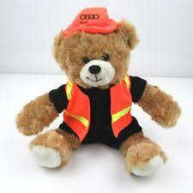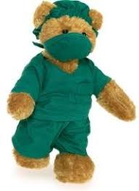
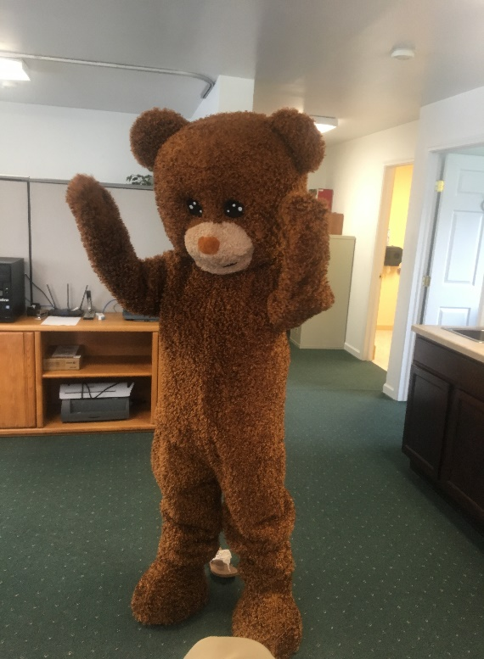
We are now introducing our Life Size Carl the Career Bear! Carl will be available upon request and availability to participate in career related events. Carl cannot attend an event alone therefore 2 staff will have to be available to attend the event. The process is simple:
1. Email or Call Colleen Prechtl (cprechtl@ncwdb.org or 814-594-0134) or Jocelyn Bash (jbash@ncwdb.org or 814-594-9651 with the request.
2. Request should include the following information: Description of the event, date, time and location of the event and indicate if you are able to provide someone to accompany Carl during the event.
3. Workforce Solutions will approve the request based on the availability of Carl and staff as well as how the event relates to workforce, careers, etc.
4. Questions and comments should be sent to Pam Streich, Director of Strategic Planning and Project Development – pstreich@ncwdb.org or 814-245-1835.

